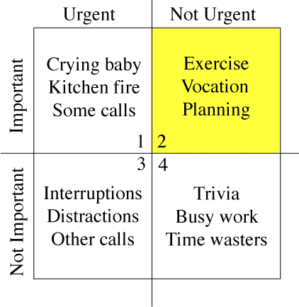
- In Quadrant 1 (top left) we have important, urgent items – items that need to be dealt with immediately.
- In Quadrant 2 (top right) we have important, but not urgent items – items that are important but do not require your immediate attention, and need to be planned for. This quadrant is highlighted because Covey emphasizes this is the quadrant that we should focus on for long term achievement of goals
- In Quadrant 3 (bottom left) we have urgent, but unimportant items - items which should be minimized or eliminated. These are the time sucks, the “poor planning on your part does not constitute an emergency on my part” variety of tasks.
- In Quadrant 4 (bottom right) we have unimportant and also not urgent items – items that don’t have to be done anytime soon, perhaps add little to no value and also should be minimized or eliminated. These are often trivial time wasters
http://sidsavara.com/personal-development/nerdy-productivity-coveys-time-management-matrix-illustrated-with-xkcd-comics
Using the tool : consciously strive to maximize Quadrant 2 time. Allocate time in your diary to carry out these tasks when you are at your best. Doing so can reduce the amount of time taken up by firefighting quadrant 1 activities, since many quadrant 1 activities could have been quadrant 2 if they had been done earlier. You can also seek to reduce time spent in Quadrant 3 by improving your systems and processes for dealing with distractions, and you can seek to eliminate as much as possible of quadrant 4 activities, by either not spending time on these things, or changing the nature of them to make them more productive.
Every task falls into one of these four quadrants. Of course, items in Quadrant I – urgent and important - should be done first. But what should you do next?
Covey suggests, and we agree, that Quadrant II should come next – important but not urgent items. So skip Quadrant III – the urgent but not important items.
The chart illustrates a very critical point about prioritization: you should consider what will move your life forward (important matters) before whatever happens to be pulling at you right now (urgent matters).
The objective is to assess what you should do to move you closer to your goals. Tackle these tasks even if there are other items demanding your time and attention. If the items screaming for your time won't bring you closer to your goals, then delay until you address all the important items first.

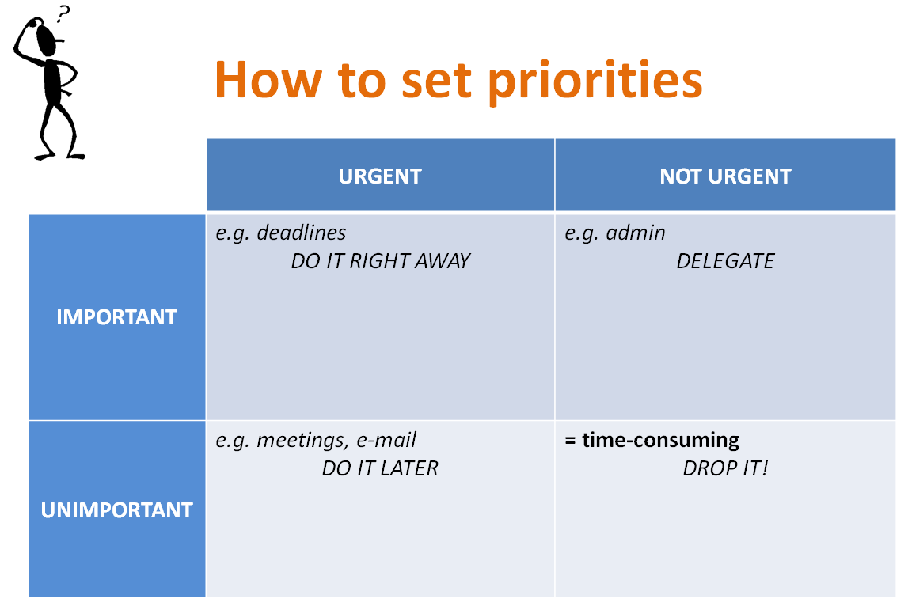
http://businet.org.uk/public/durham2009/Petra%20Gillis,%20Leen%20Van%20Tolhuysen%20-%20Time%20Management.ppt

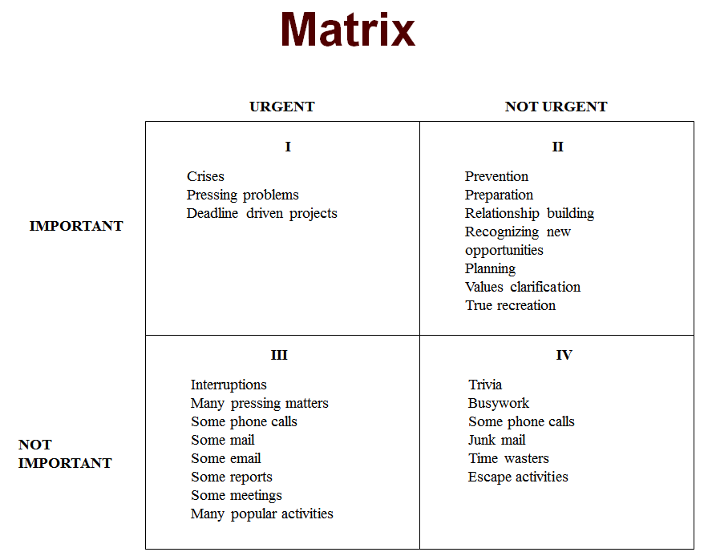

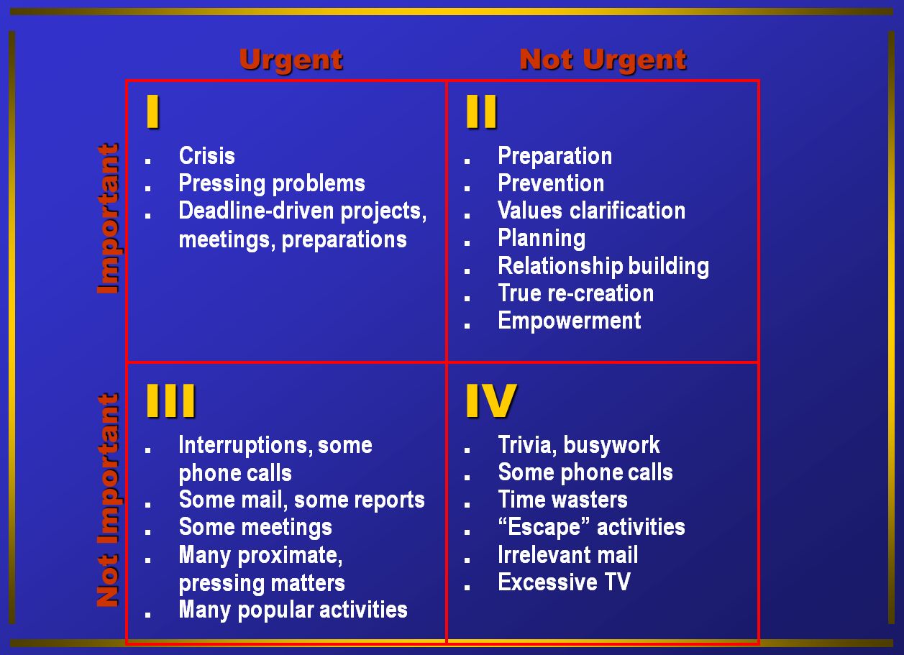
www.dallashanuman.org/yoga/resources/7-Habits-COMPLETE.ppt

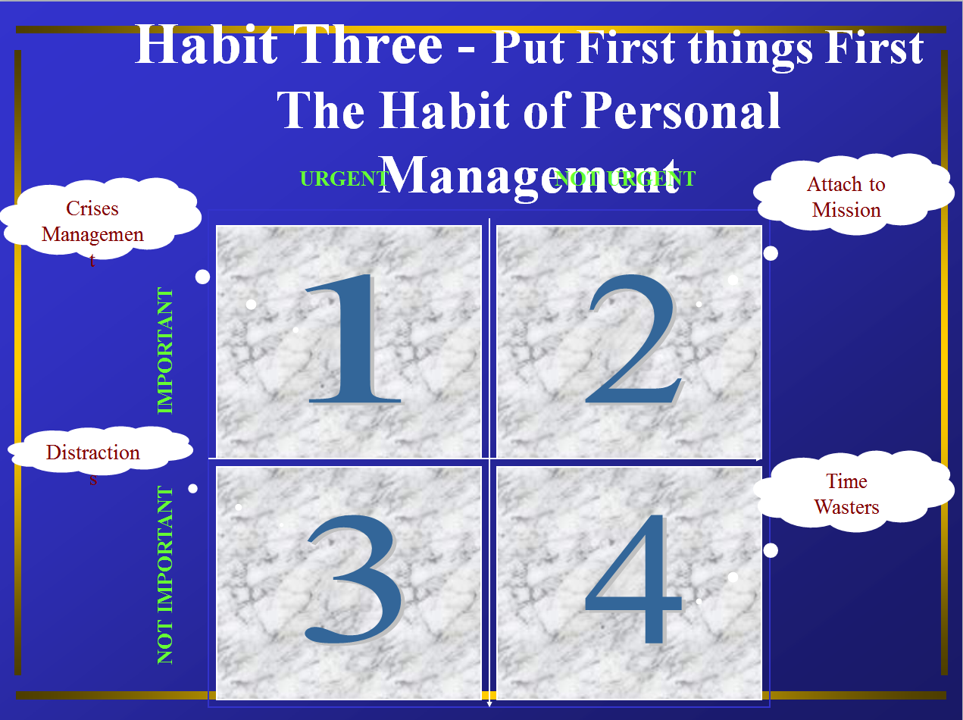
www.dallashanuman.org/yoga/resources/7-Habits-COMPLETE.ppt

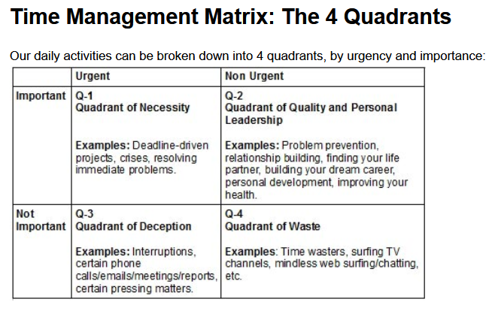
http://personalexcellence.co/blog/put-first-things-first/

